Art style to our game

## Demographic

The demographic for our game are females in between the ages of 21-35 because they are the dominant demographic for casual games. Employment status:student/work Salary: under £25,000

## Psychographic

Personality, Values, Attitudes, Interests, Lifestyles

* *Casual Users don’t have years of gaming experience*
* *Casual Users don’t have the dexterity of gamers*
* *Casual Users play on their phone to pass time*

Busy with work or academic work, busy schedule

Interests: Music, Reading, Shopping, TV Shows, Movies, working out

Partying, enjoying their youth

Travelling to different countries

Commute/drive to work/uni

## Games that demographic plays

Players on Facebook in the US

* Bejeweled Blitz
* Farmville
* Yoville
* Treasure Isle
* Restaurant City
* Country Story

(DataGenetics, 2013)

## Art styles of games that demographic play

Facebook Games -

## 

Popular Casual Mobile Games –

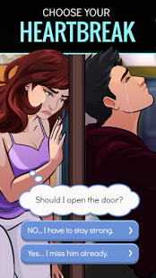 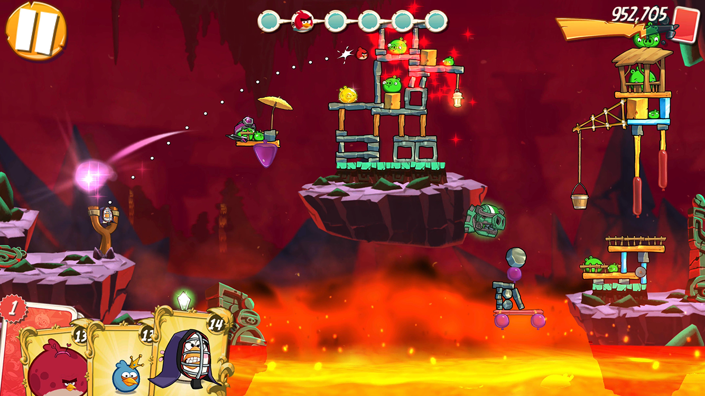

(Lelya, 2016)

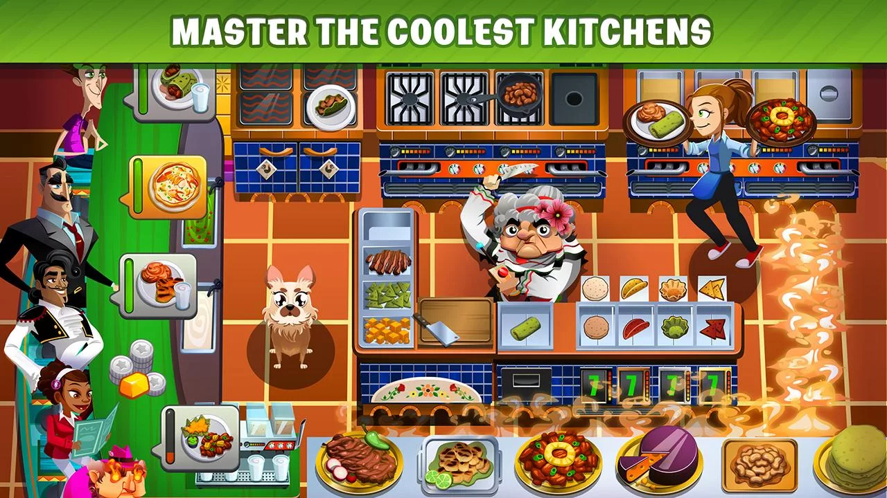

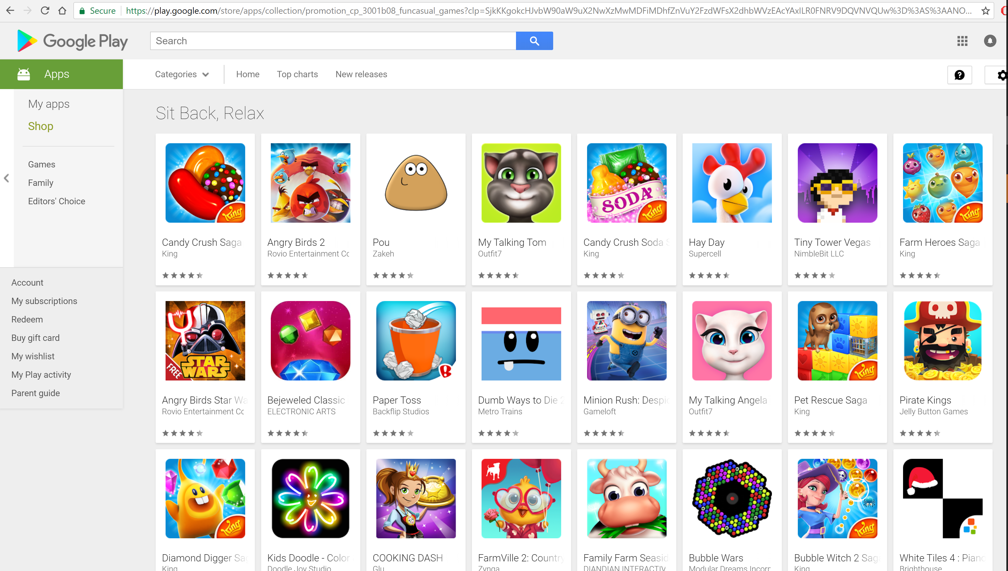

## Cooking games

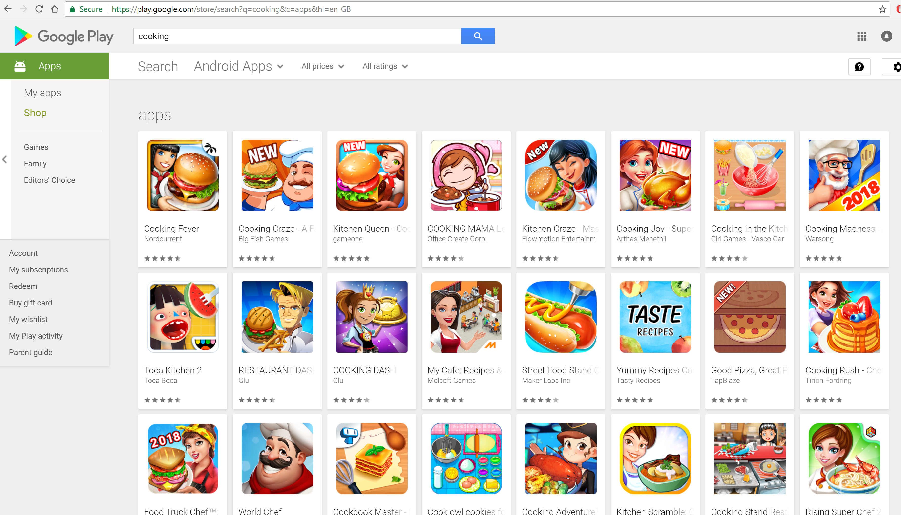

## Summary

Cooking games and Casual games have very similar design styles. They are cartoony, 2d cell shaded graphics with hints of realism for characters, on some apps, however, mostly characters are very cartoony. Some like a realistic feel in cooking app games like cooking mama to simulate the player cooking. On some cooking apps its just managing a business. Casual games tend to simulate events at first hand but also give the users a god view e.g. Angry birds.

## References

Data references

Datagenetics(2013) *Facebook Casual Game Demographics.* Available at: <http://www.datagenetics.com/blog/december12010/> (Accessed:04/02/2018)

Lelya(17th September, 2016) *Poll: Episode Demographics.* Available at: <http://forums.episodeinteractive.com/forum/main-category/episode-fan-community/1074534-poll-episode-demographics> (Accessed: 04/02/2018)

Image references

ElectronicArts(24th January 2018) *Bejeweled Blitz.*  Available at: <https://play.google.com/store/apps/details?id=com.ea.BejeweledBlitz_row&hl=en_GB> (Accessed: 04/02/2018)

Gameslikefinder (7th August, 2014) *Farmville 2.* Available at: <http://gameslikefinder.com/farmville-2/> (Accessed: 04/02/2018)

DeanTakahashi (7th May, 2012) *Hackers disrupt the gameplay of Zynga’s Yoville social game.* Available at: <https://venturebeat.com/2012/05/07/hackers-disrupt-the-gameplay-of-zyngas-yoville-social-game/> (Accessed: 04/02/2018)

JustinDavis(14th April, 2010)  *Facebook Games: Treasure Isle.* Available at: <http://uk.ign.com/articles/2010/04/14/facebook-games-treasure-isle> (Accessed: 04/02/2018)

Azfar(15thOctober, 2009) *Restaurant City gameplay.* Available at: <https://www.youtube.com/watch?v=mLnHJC-h0iE> (Accessed: 04/02/2018)

Azfar(15th October, 2009) *Country Story gameplay.* Available at: <https://www.youtube.com/watch?v=Ecic_25y8Cw> (Accessed: 04/02/2018)

EpisodeInteractive(31st January 2018) *Episode – Choose your story.*  Available at: <https://play.google.com/store/apps/details?id=com.episodeinteractive.android.catalog&hl=en_GB> (Accessed: 04/02/2018)

Rovio Entertainment Corporation(22nd January, 2018) *Angry Birds 2.* Available at: <https://play.google.com/store/apps/details?id=com.rovio.baba> (Accessed: 04/02/2018)

Glu(9th January, 2018) *Cooking Dash.* Available at: <https://play.google.com/store/apps/details?id=com.playfirst.cookingdashx> (Accessed: 04/02/2018)

GooglePlay(2018) *Casual Games.* Available at: <https://play.google.com/store/apps/collection/promotion_cp_3001b08_funcasual_games?clp=SjkKKgokcHJvbW90aW9uX2NwXzMwMDFiMDhfZnVuY2FzdWFsX2dhbWVzEAcYAxILR0FNRV9DQVNVQUw%3D%3AS%3AANO1ljINP8o&hl=en_GB> (Accessed: 04/02/2018)

GooglePlay (2018) *Cooking Games.* Available at: <https://play.google.com/store/search?q=cooking&c=apps&hl=en_GB> (Accessed: 04/02/2018)